**Example 1:**

Find the names of sailors who reserved a red or a green boat

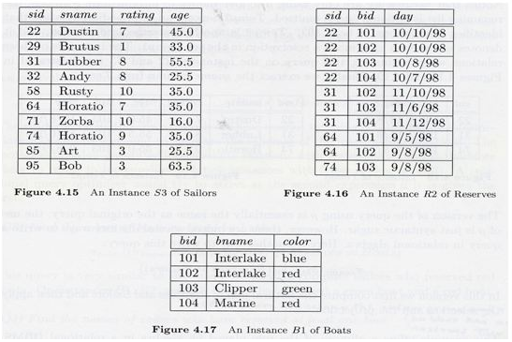

**Answer:**

$$ρ_{\left\{Tempboats\right\}}(σcolor=red\left(boat\right)∪ (σcolor=green\left(boat\right))$$

$π_{\left\{sname\right\}} (Tempboats ∞ reserves ∞ sailor$)

**Example 2:**

Rename the relation Student as Male Student and the attributes of Student – RollNo, SName as (Sno, Name).

**Answer**

$$ρ_{\left\{MaleStudent\left(Sno, Name\right)\right\}}( π_{\left\{RollNo, SName \right\}}(Student))$$

**Example 3:**

Query to rename the attributes Name, Age of table Department to A,B.

**Answer**

$$ρ_{\left\{A,B\right\}}(Department)$$

**Example-4:**

Query to rename the table name Project to Pro and its attributes to P, Q, R.

**Answer:**

$$ρ_{\left\{Pro(P,Q,R\right\}}(Project)$$

**Example-5:**

Query to rename the first attribute of the table Student with attributes A, B, C to P.

**Answer:**

$$ρ_{\left\{P,B,C\right\}}(Student)$$